

VR ASSEMBLY OF AIRCRAFT

Project Report



December 10, 2018

BOWIE STATE UNIVERSITY

Dr Sharad Sharma

COSC 590

BY:

Manik Arrolla

Sri Teja B

olalekan

**Abstract:**

The aim of this project is to assemble aircraft using vizible, up to now we are using two different software’s, for assembling 3D models we use separate software and for presentation we use 2D. The aim of this project is to get done both assembling and presentation simultaneously. This will be done using vizible. This will let user to present his 3D model in a presentation slides and also let user to modify the 3D model while presenting.

**Introduction:**

Vizible is simple yet powerful VR creation and collaboration software. There are two parts to Vizible, one to create VR content and another to experience it. With **Vizible Presentation Designer**, you create rich, interactive VR presentations. Then, with **Vizible Presenter**, you hold sessions, multi-user gatherings inside of your presentations for real time communication and collaboration in virtual reality.

**Vizible Presentation Designer** is what we use for VR creation. Presentation Designer has a user interface that might remind us of PowerPoint or Google Slides.  Each "slide" in Presentation Designer is a 3D scene that you can populate with 3D models, spherical videos, 2D videos, images, sounds, documents, and more.In this project we will add 3ds models of the aircraft designing. We will add interactivity to the presentation via triggers and sensors. We can even enter the VR environment as an avatar for presenter and attendee. Like with a Google Doc, multiple users can work on the same Vizible presentation at one time.

Once ready to share presentation, create "sessions". A session is an exclusive time in which the results of your work in Presentation Designer can be experienced in VR hardware or on desktop, alone or with others. All content created in Presentation Designer is inherently multi-user, but you can also experience it on your own. At the time of the session, to join it as the presenter or host, you use **Vizible Presenter**. Attendees use**Vizible Attendee.**

Once inside a session, participants have voice chat (spatialized) and see each other as avatars with tracked controllers. Participants have tools available like laser pointers, pencils, grabbers, and movement tools.

**Implementation And Deploying**

There are so many tools available for presentation in 2D, but using 3D objects in the 2D slides are very hard to show. This can be done easily in Vizible. This contains presentation slides, which allows us to create slides, these slides allow us to insert 3D models in the presentation.

This visible is divided into three parts as designer, presenter and attender. Each one will have different features to do. They are

**Designer**

This designer part will allow us to design our slides and also allow user to build their 3D object in the slide according their needs. In this user don’t need any external software to edit 3D object, visible will support in editing the object. If necessary user can run small 3D animation in the slide with preprogramed objects.

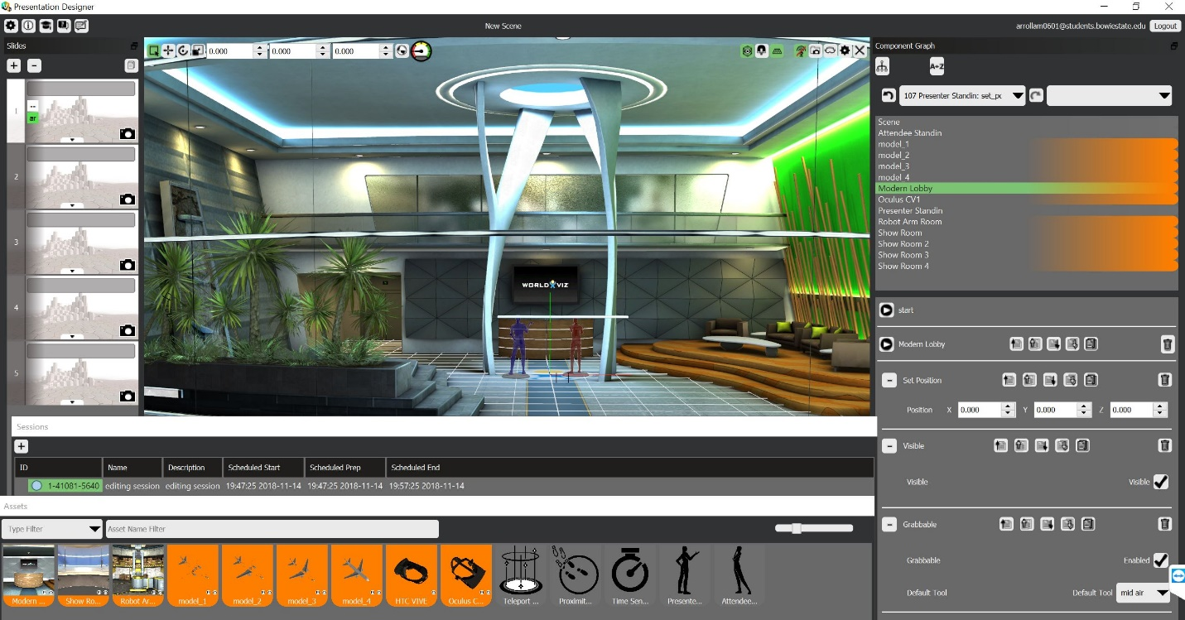

*Fig1: Default view, lobi.*

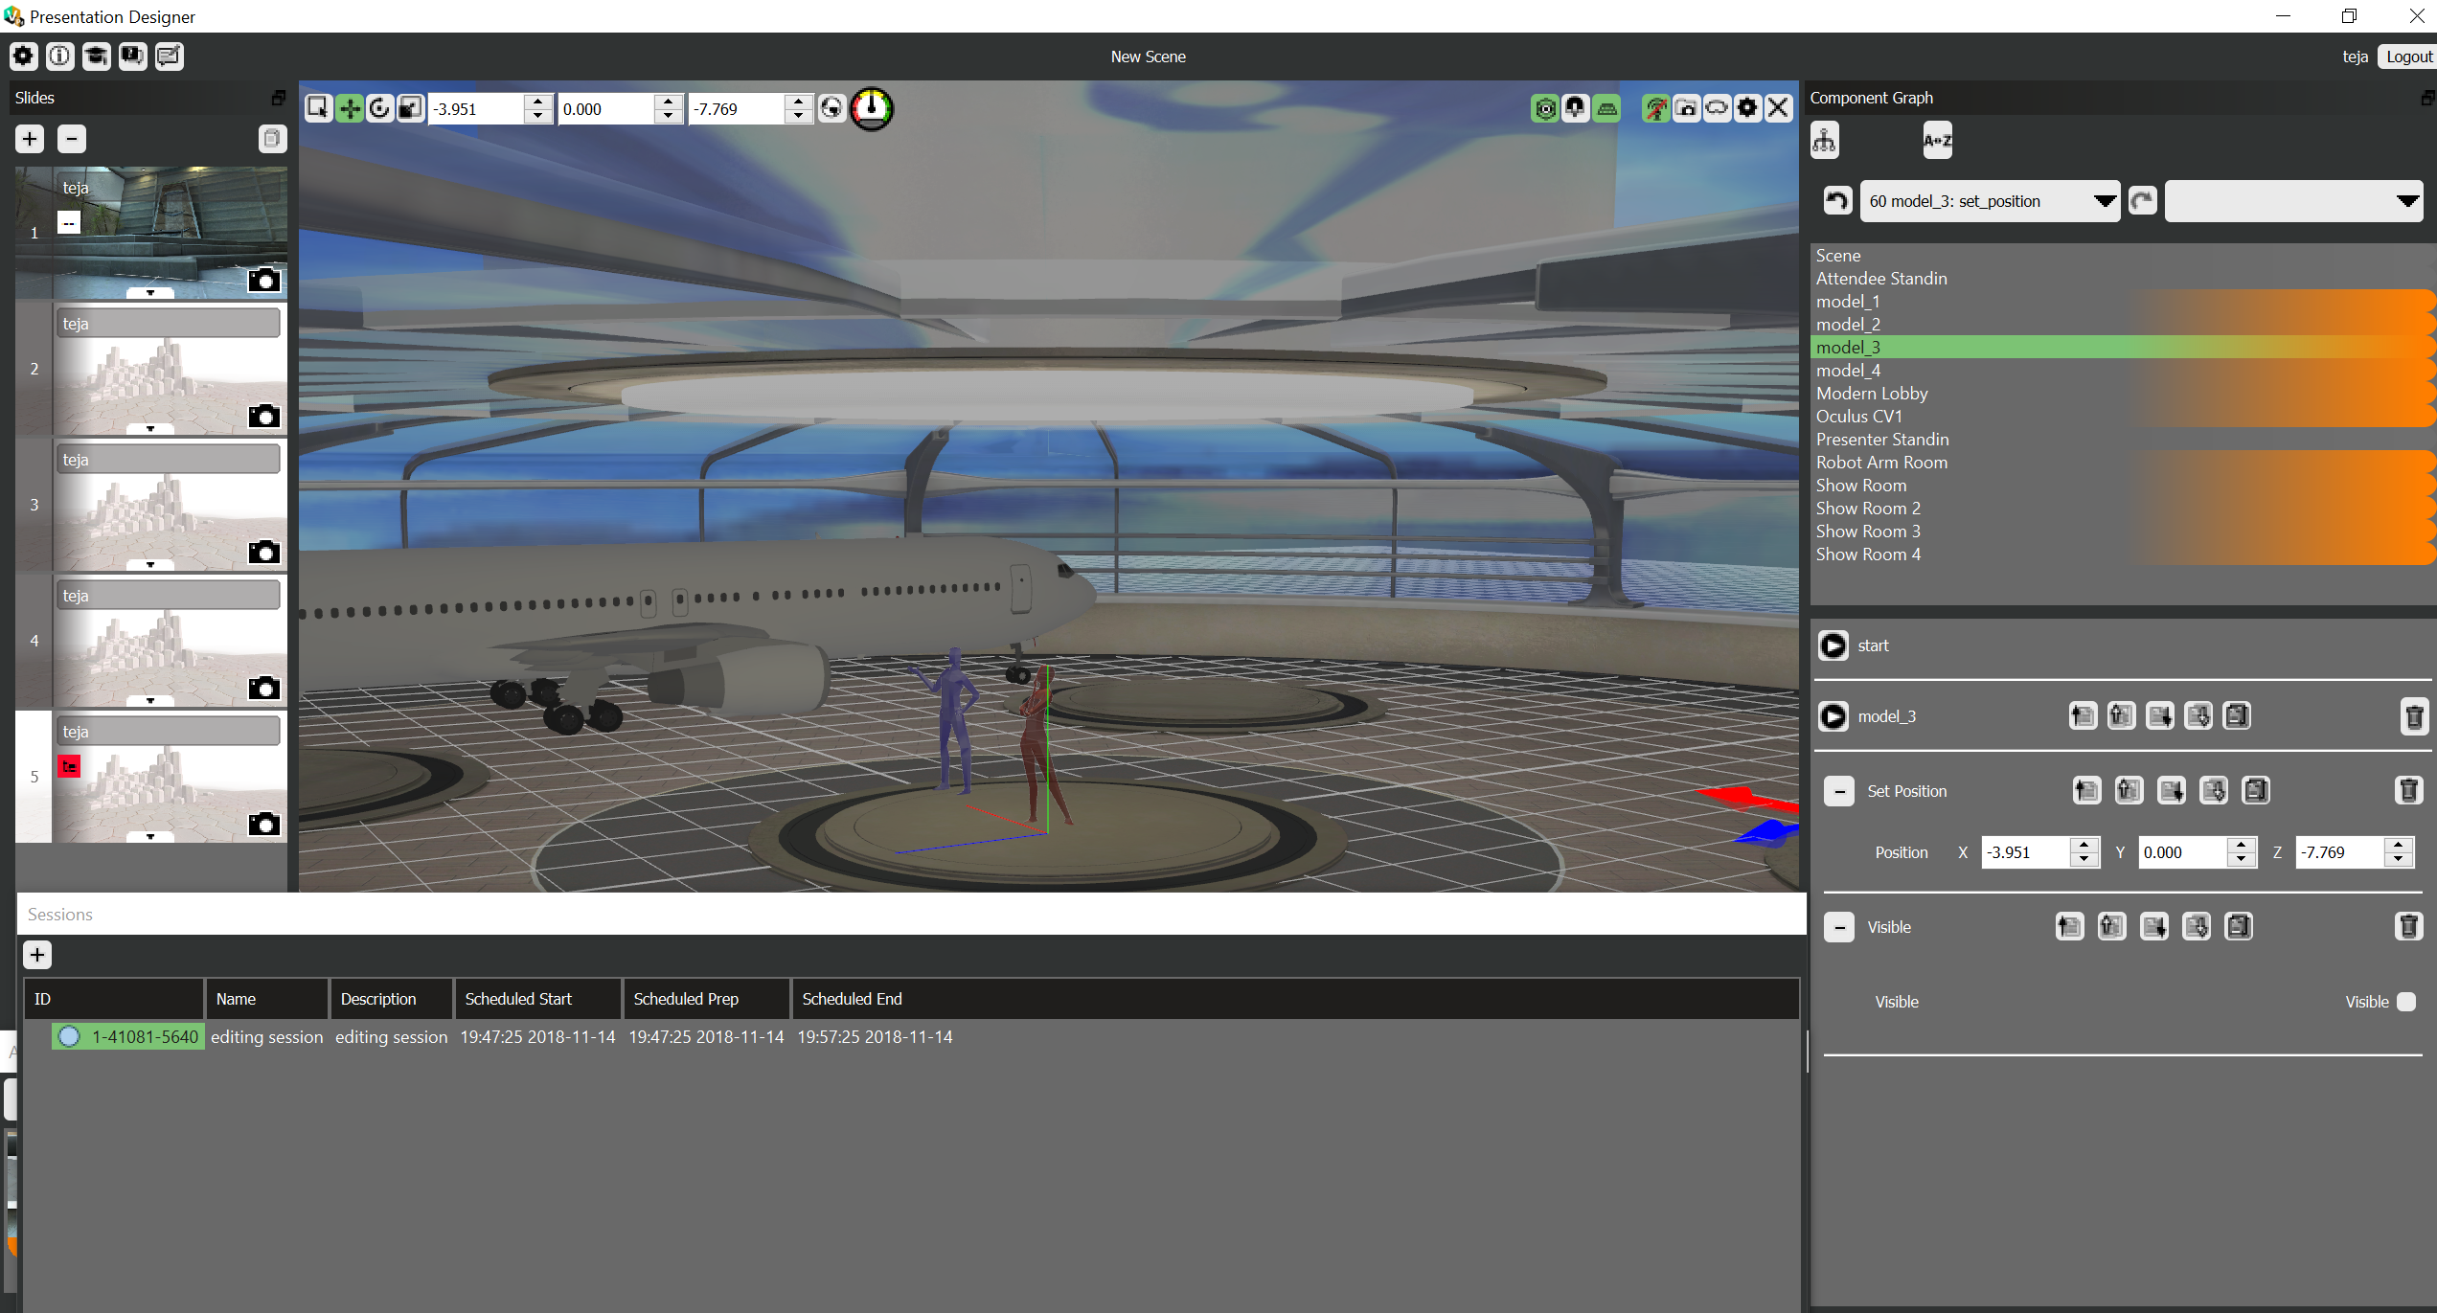

Fig2: work shop, where 3D object can be built

In this designer mode, it will provide different rooms to work on different 3D objects. In each room we can have one object, so that we can keep all objects separately, if necessary we can copy the object from one room to another room. For each room we can prepare different slides, all those slides can be groped at the end in a sequential order to prepare presentation.

This visible will give an access to connect to all other devices like oculus, google glass etc. Each individual device need different code to run but this visible will convert existing code into targeted device compatible code.

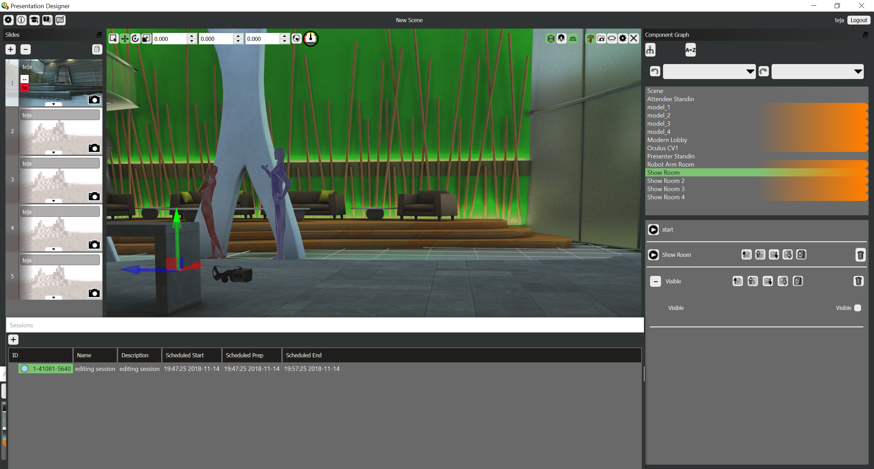

*Fig3: After connected to oculus.*

**Presenter:**

In the fig3, there are two virtual humans are available, they are presenter and viewer. This visible has a feature to have multiple presenters and viewers. When we have session ID from designer, presenter can log in into his account and see the slides available to present. When presenter log in from his terminal, it enable his microphone and speaker to interact with viewer.

While presenter giving his presentation, he has an ability to move object in the slide. Also he can switch or transport one place to other place in the work room. While presenter giving his presentation he can interact with viewer or other presenter who logged in as a presenter, using his microphone and speaker. So that they can interact by voice. Designer also will have an access to attend the presentation this will allow him to make some last mint changes if needed.

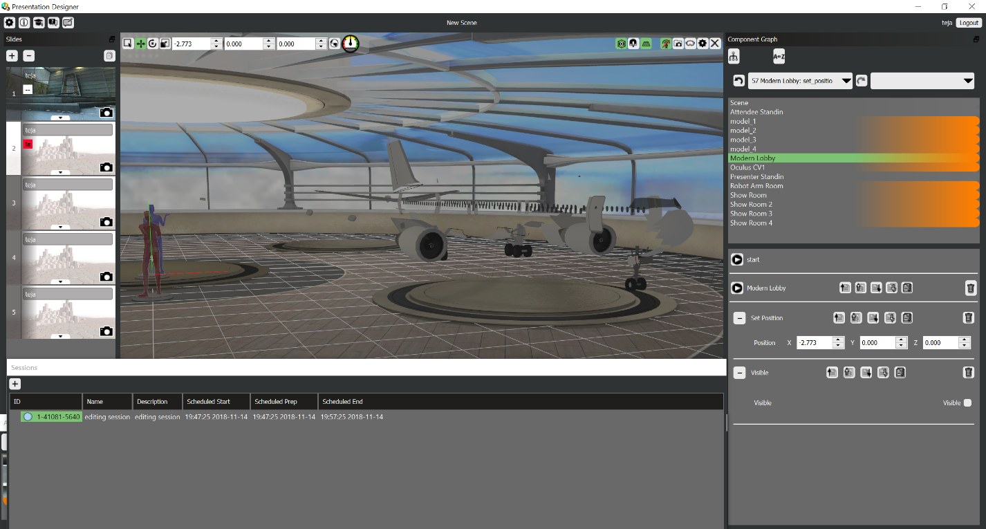

*Fig4: presenter giving his presentation.*

Presenter also have a feature to pre load his location to move in the work room. Presenter can load his movements with time manner so that it switches presenter location and view will change automatically according time loaded.

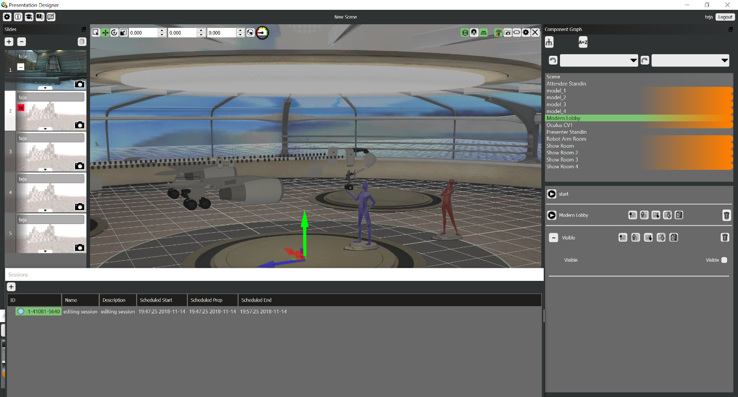

*Fig5: after presenter moved from his location.*

**Attender:**

The visible has a feature to load many attenders, ones they got session ID from presenter or designer, they can log in from their terminal. Viewer has different facilities compared to other tools available in the market. Usually viewer can see only what presenter showing in the presentation in the regular tools, but in this visible the attender can move around in the room and explore the room by his own. But attender cannot edit or move the object in the seen.

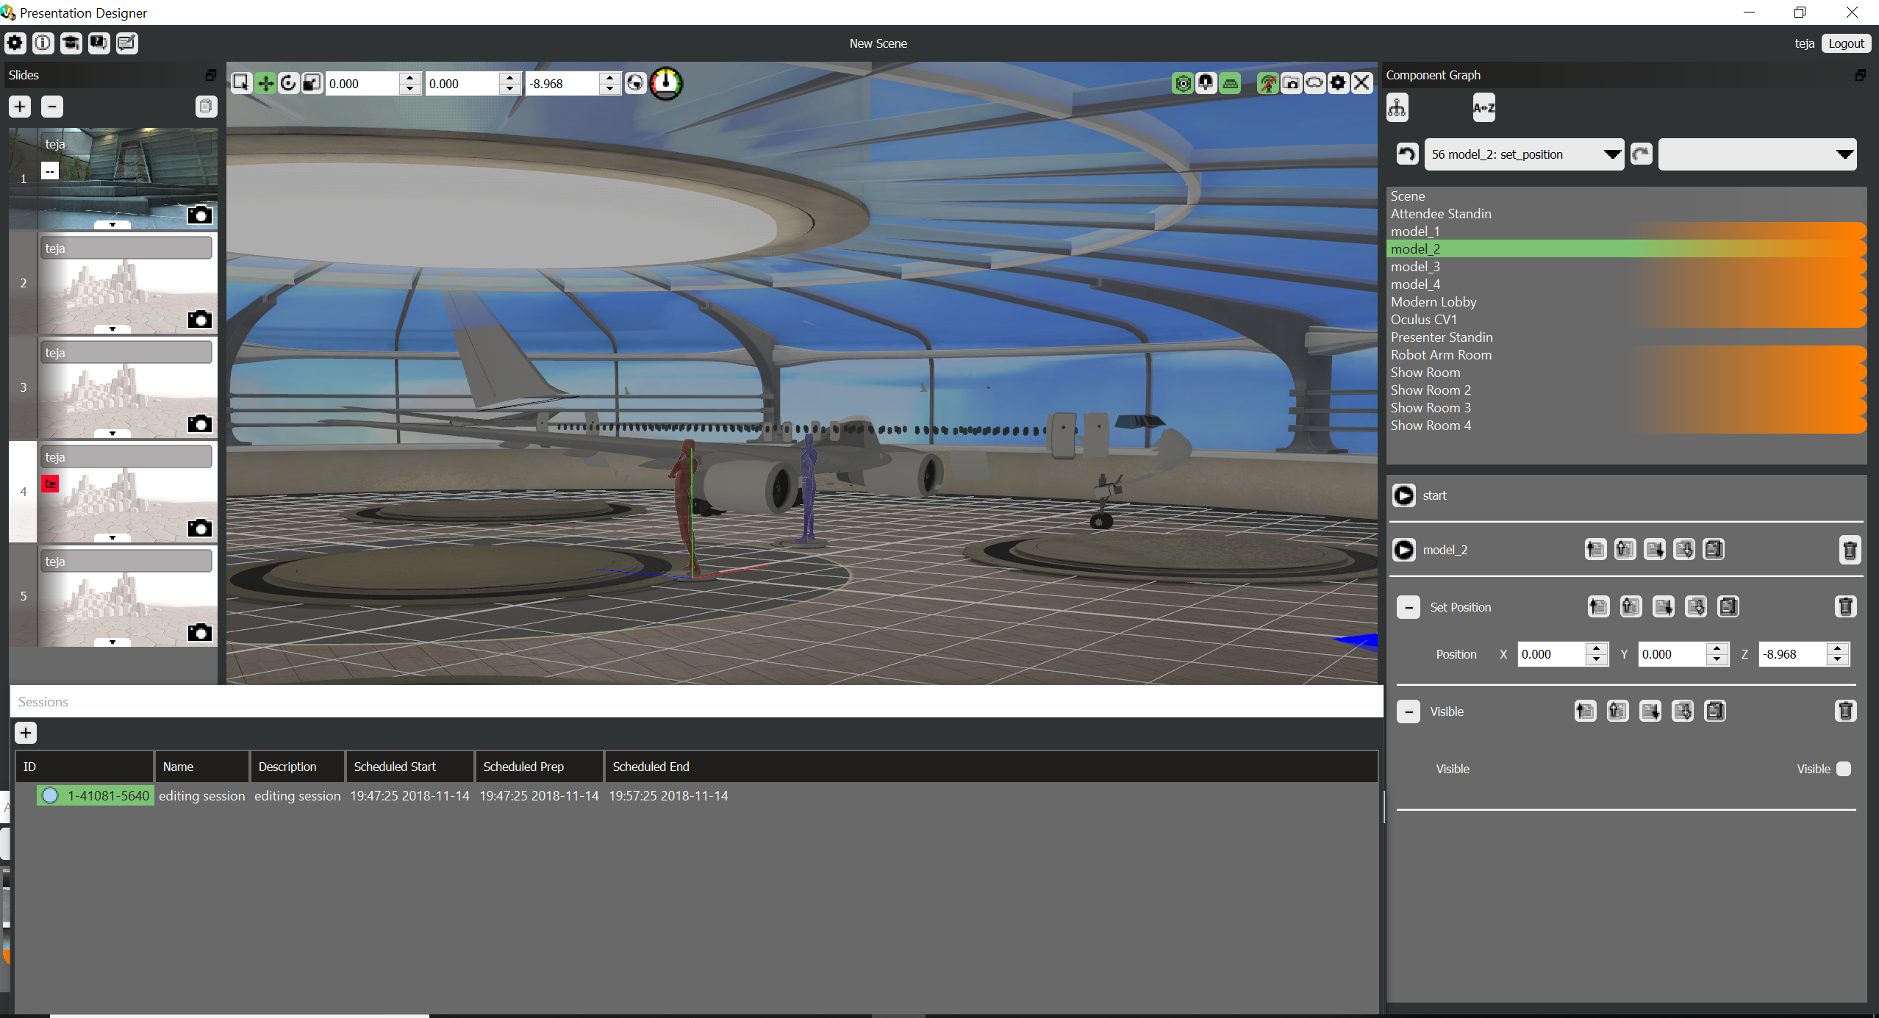

*Fig6: Attender exploring object.*

Presenter can set some proximity sensor for attender, when attender reaches certain location into the proximity location, he gets information about certain object in that location. This can be opening text window or voice clip, describing the object.

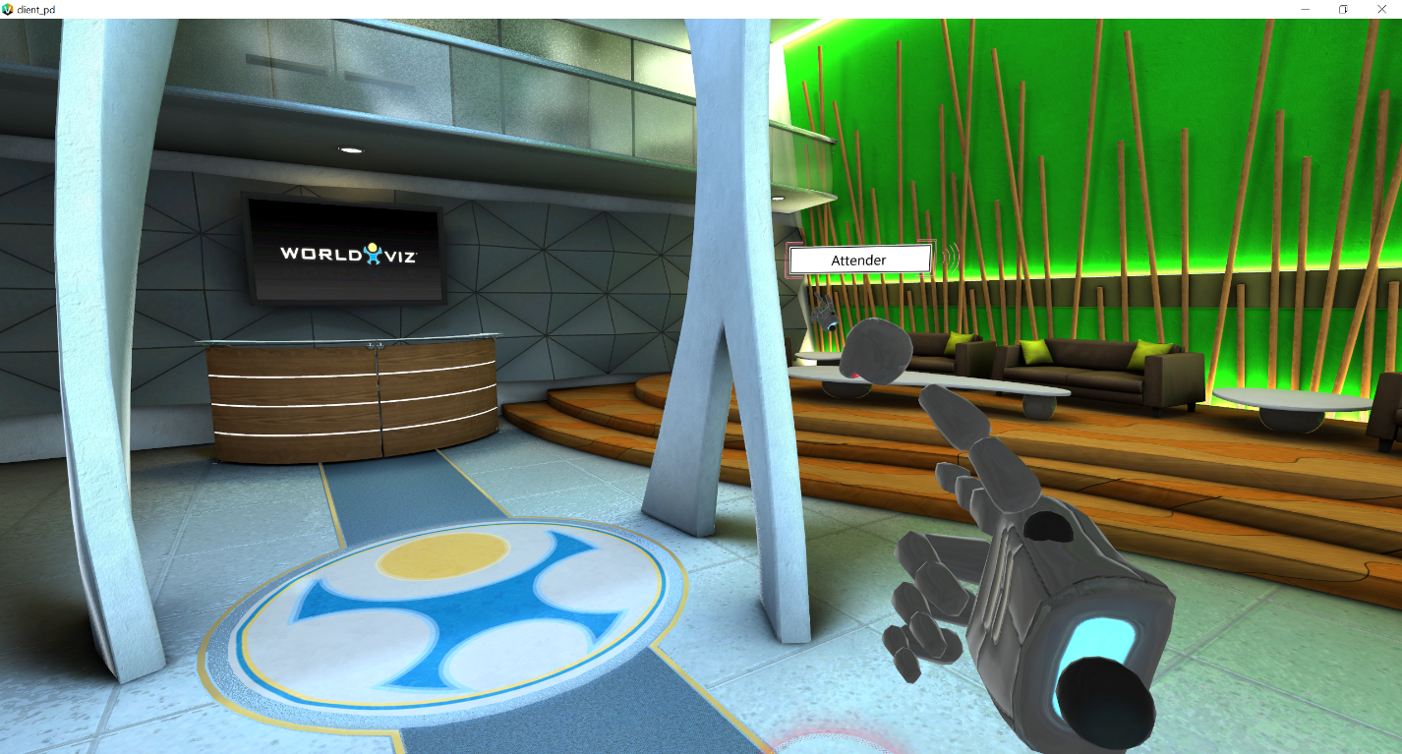

*Fig7: presenter view. Looking at attender*

**Conclusion:**

Finally, we are able to perform assembling of aircraft, using visible. Tried with two attenders, and able to present successfully.

**Appendix**

**Screenshots:**

Lobby view for in the beginning seen

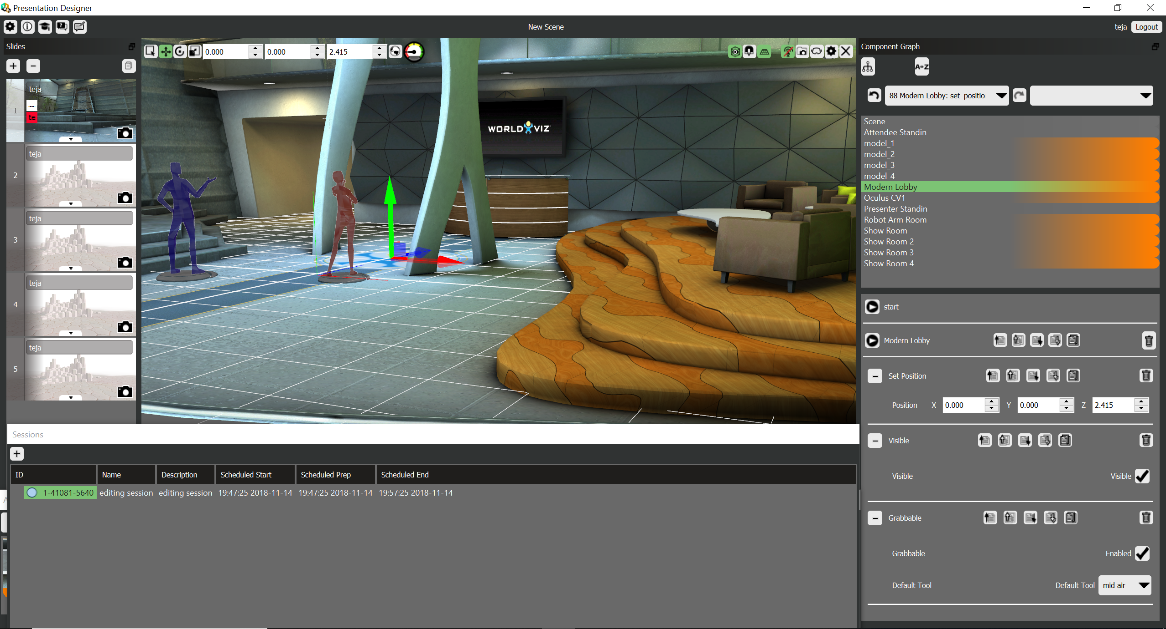

Assembling plane in the work shop

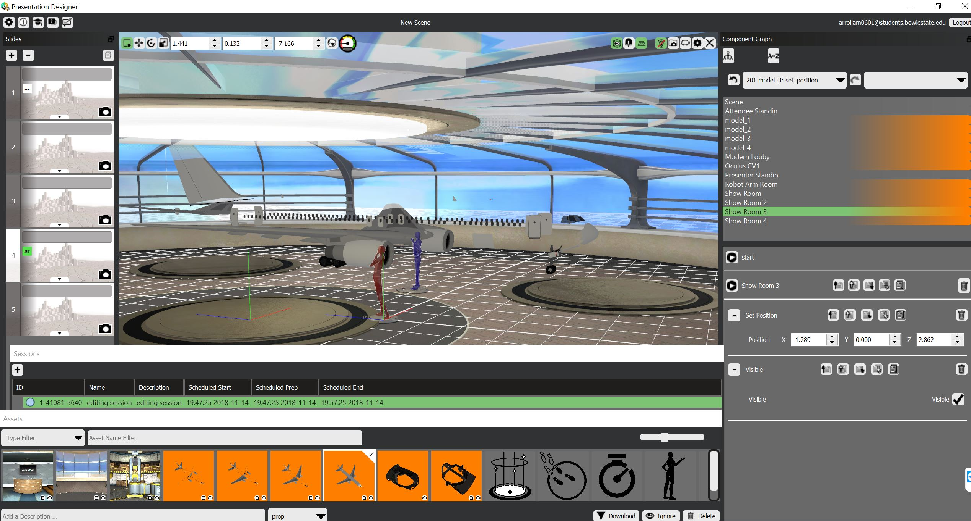

Presenter giving demo about flight

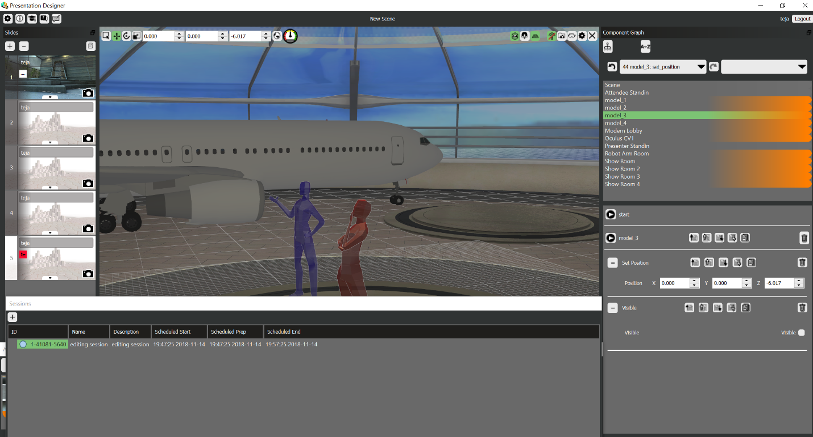

After finishing the flight assembling.

